Git Issues

What is a Git Issue
# Source: AI Source: Provided by: [Data Path: Persons Table -> ID Column: 1, Name_En Column: Motasem Essam] -> From: [Chatgpt (GPT‑5 Mini)] on [3/6/2026]
- A Git issue is like a digital sticky note attached to your repository.
- It usually contains:
  - Title – short description of the problem or task
  - Description – detailed info about the issue
  - Labels / Tags – categorize (bug, feature, enhancement)
  - Assignees – people responsible for fixing it
  - Comments – discussion, updates, or troubleshooting
  - Status – open or closed

Purpose of Issues
# Source: AI Source: Provided by: [Data Path: Persons Table -> ID Column: 1, Name_En Column: Motasem Essam] -> From: [Chatgpt (GPT‑5 Mini)] on [3/6/2026]
- Track bugs: e.g., “Login button doesn’t work on mobile.”
- Plan new features: e.g., “Add dark mode support.”
- Organize work: link commits, branches, and MRs (Merge Requests) to issues.
- Collaboration: team members can discuss, suggest fixes, and update progress.

How Issues Work in GitLab
# Source: AI Source: Provided by: [Data Path: Persons Table -> ID Column: 1, Name_En Column: Motasem Essam] -> From: [Chatgpt (GPT‑5 Mini)] on [3/6/2026]
On GitLab, every repository has an Issues tab:
- Create a new issue – describe the bug or task
- Assign it to someone – team member responsible
- Link commits/merge requests – Fixes #123 in a commit automatically closes issue #123
- Label it – bug, enhancement, documentation, etc.

GitHub CLI: Working with Issues
# Source: AI Source: Provided by: [Data Path: Persons Table -> ID Column: 1, Name_En Column: Motasem Essam] -> From: [Chatgpt (GPT‑5 Mini)] on [3/6/2026]
The GitHub CLI lets you manage issues directly from the terminal without opening the browser. The CLI tool for GitHub is GitHub CLI (command: gh), used with repositories hosted on GitHub.
Below are the most useful commands when working with issues.

1️⃣ Create a New Issue
# Source: AI Source: Provided by: [Data Path: Persons Table -> ID Column: 1, Name_En Column: Motasem Essam] -> From: [Chatgpt (GPT‑5 Mini)] on [3/6/2026]
Create from the terminal:
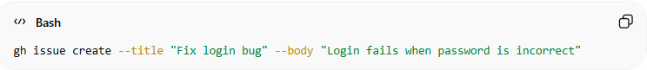
gh issue create --title "Fix login bug" --body "Login fails when password is incorrect"
Interactive mode:
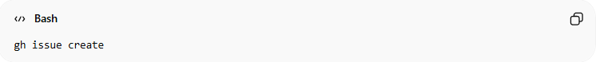
gh issue create
The CLI will ask:
- Title
- Description
- Labels
- Assignee

2️⃣ List Issues
# Source: AI Source: Provided by: [Data Path: Persons Table -> ID Column: 1, Name_En Column: Motasem Essam] -> From: [Chatgpt (GPT‑5 Mini)] on [3/6/2026]
Show all open issues in the current repository:
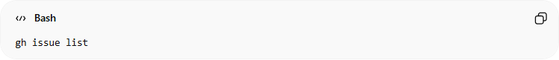
gh issue list
Example output:
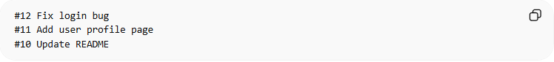
#12 Fix login bug
#11 Add user profile page
#10 Update README
You can also filter:
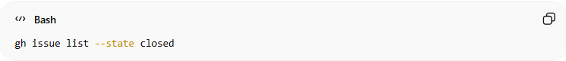
gh issue list --state closed

3️⃣ View an Issue
# Source: AI Source: Provided by: [Data Path: Persons Table -> ID Column: 1, Name_En Column: Motasem Essam] -> From: [Chatgpt (GPT‑5 Mini)] on [3/6/2026]
To see details of an issue:
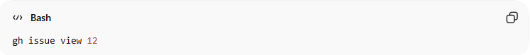
gh issue view 12
This shows:
- Title
- Description
- Labels
- Comments
- Status
Open it in the browser:
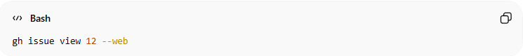
gh issue view 12 --web

4️⃣ Edit an Issue
# Source: AI Source: Provided by: [Data Path: Persons Table -> ID Column: 1, Name_En Column: Motasem Essam] -> From: [Chatgpt (GPT‑5 Mini)] on [3/6/2026]
The GitHub CLI (gh) allows you to modify an existing issue directly from the terminal, such as updating the title or description.
Modify the issue title:
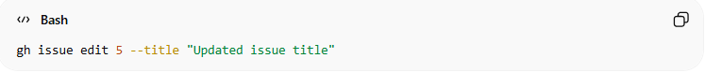
gh issue edit 5 --title "Updated issue title"
Modify the issue description:
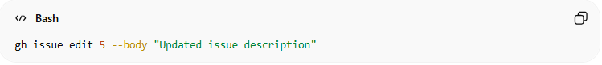
gh issue edit 5 --body "Updated issue description"
Modify both title and description:
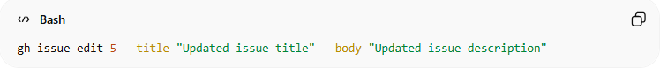
gh issue edit 5 --title "Updated issue title" --body "Updated issue description"
Explanation:
- gh issue edit → Updates an existing issue
- 5 → The issue number
- --title → Changes the issue title
- --body → Changes the issue description

5️⃣ Assign an Issue
# Source: AI Source: Provided by: [Data Path: Persons Table -> ID Column: 1, Name_En Column: Motasem Essam] -> From: [Chatgpt (GPT‑5 Mini)] on [3/6/2026]
Assign an Issue means giving responsibility for the issue to a specific person. It tells your team who is responsible for fixing the bug, implementing the feature, or completing the task.
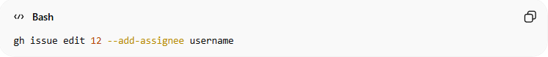
gh issue edit 12 --add-assignee username
Assign to yourself:
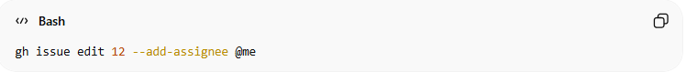
gh issue edit 12 --add-assignee @me
Remove Yourself from the Issue:
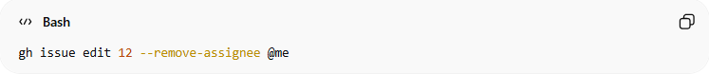
gh issue edit 12 --remove-assignee @me

6️⃣ Add Labels
# Source: AI Source: Provided by: [Data Path: Persons Table -> ID Column: 1, Name_En Column: Motasem Essam] -> From: [Chatgpt (GPT‑5 Mini)] on [3/6/2026]
Add Labels means categorizing an issue to make it easier to organize, filter, and track in your repository.
Single label:
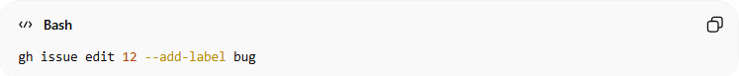
gh issue edit 12 --add-label bug
Multiple labels:
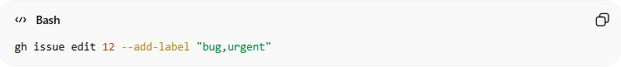
gh issue edit 12 --add-label "bug,urgent"

Remove a single label
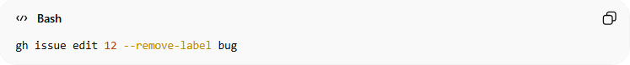
gh issue edit 12 --remove-label bug
Remove multiple labels
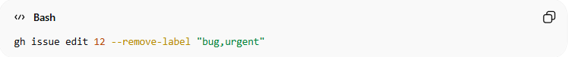
gh issue edit 12 --remove-label "bug,urgent"

7️⃣ Comment on an Issue
# Source: AI Source: Provided by: [Data Path: Persons Table -> ID Column: 1, Name_En Column: Motasem Essam] -> From: [Chatgpt (GPT‑5 Mini)] on [3/6/2026]
Comment on an Issue means adding a message or note to an existing issue to communicate with other developers.
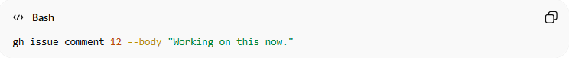
gh issue comment 12 --body "Working on this now."

# Source: AI Source: Provided by: [Data Path: Persons Table -> ID Column: 1, Name_En Column: Motasem Essam] -> From: [Chatgpt (GPT‑5 Mini)] on [3/6/2026]
GitHub automatically links commits and pull requests to issues.
Example:
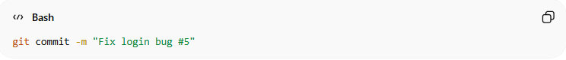
git commit -m "Fix login bug #5"
When the PR is merged, issue #5 will automatically close.

8️⃣ Close an Issue
# Source: AI Source: Provided by: [Data Path: Persons Table -> ID Column: 1, Name_En Column: Motasem Essam] -> From: [Chatgpt (GPT‑5 Mini)] on [3/6/2026]
Close an Issue means marking an issue as resolved or finished so it is no longer considered an active problem.
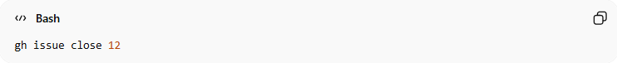
gh issue close 12
Reopen:
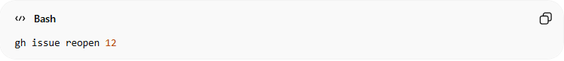
gh issue reopen 12

Example Workflow 🚀
# Source: AI Source: Provided by: [Data Path: Persons Table -> ID Column: 1, Name_En Column: Motasem Essam] -> From: [Chatgpt (GPT‑5 Mini)] on [3/6/2026]
Typical developer flow:
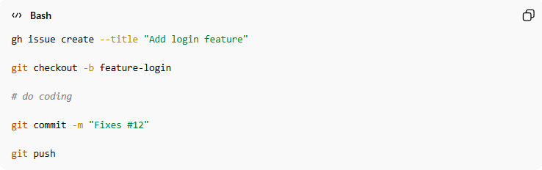
gh issue create --title "Add login feature"

git checkout -b feature-login

# do coding

git commit -m "Fixes #12"

git push
When the commit message contains:
Fixes #12
GitHub automatically closes the issue after the pull request is merged.

✅ Helpful command
# Source: AI Source: Provided by: [Data Path: Persons Table -> ID Column: 1, Name_En Column: Motasem Essam] -> From: [Chatgpt (GPT‑5 Mini)] on [3/6/2026]
Run this to see all available commands:
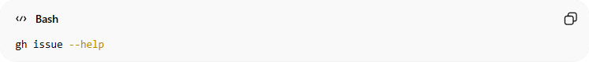
gh issue --help

Example

1️⃣ Create a New Issue

Option 1: Create from the terminal
# Source: ScreenShots Source: Provided by: [Persons Table -> ID Column: 1, Name_En Column: Motasem Essam] -> Tool: [Lightshot Program] -> From [Operating System: Windows] on [3/6/2026]
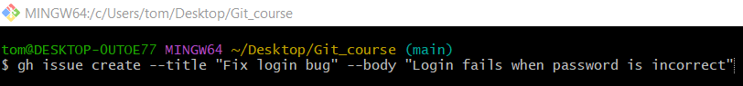
gh issue create --title "Fix login bug" --body "Login fails when password is incorrect"
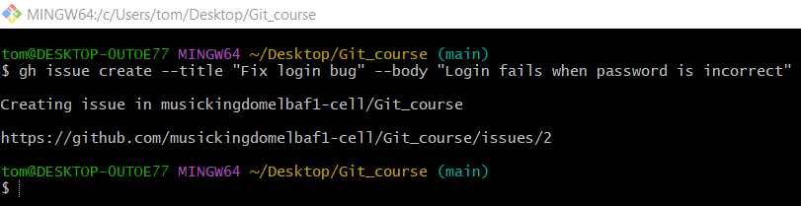

Option 2: Interactive mode
# Source: ScreenShots Source: Provided by: [Persons Table -> ID Column: 1, Name_En Column: Motasem Essam] -> Tool: [Lightshot Program] -> From [Operating System: Windows] on [3/6/2026]
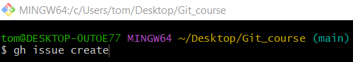
gh issue create
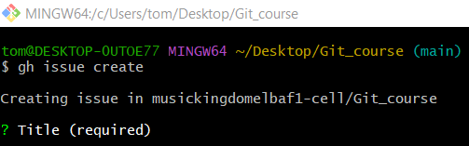
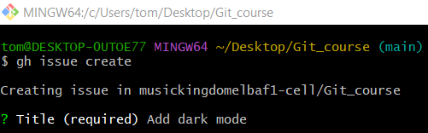
Add dark mode
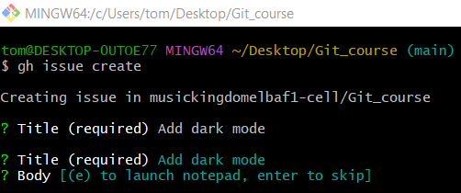
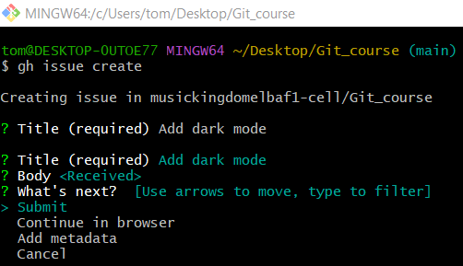
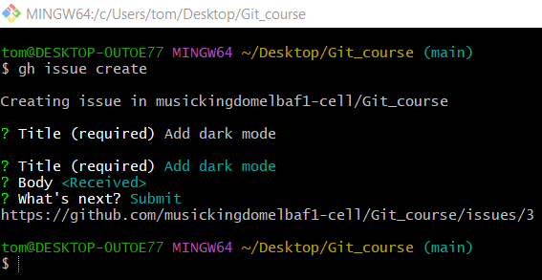
# Source: ScreenShots Source: Provided by: [Persons Table -> ID Column: 1, Name_En Column: Motasem Essam] -> Tool: [Lightshot Program] -> From [Site: https://github.com] on [3/6/2026]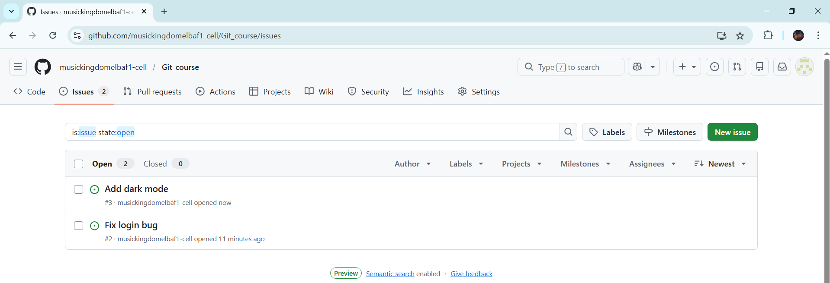

2️⃣ List Issues
# Source: ScreenShots Source: Provided by: [Persons Table -> ID Column: 1, Name_En Column: Motasem Essam] -> Tool: [Lightshot Program] -> From [Operating System: Windows] on [3/6/2026]
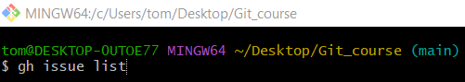
gh issue list
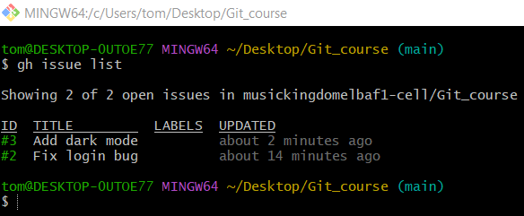

3️⃣ View an Issue
# Source: ScreenShots Source: Provided by: [Persons Table -> ID Column: 1, Name_En Column: Motasem Essam] -> Tool: [Lightshot Program] -> From [Operating System: Windows] on [3/6/2026]
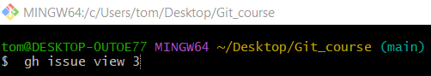
gh issue view 3
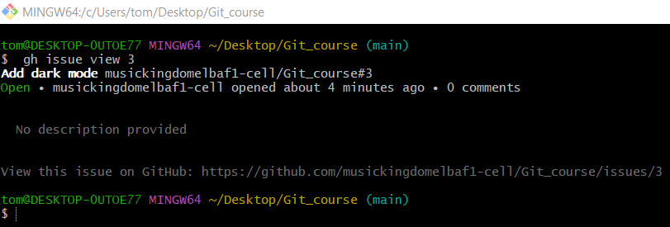

4️⃣ Edit an Issue
# Source: ScreenShots Source: Provided by: [Persons Table -> ID Column: 1, Name_En Column: Motasem Essam] -> Tool: [Lightshot Program] -> From [Operating System: Windows] on [3/6/2026]
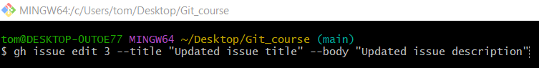
gh issue edit 3 --title "Updated issue title" --body "Updated issue description"
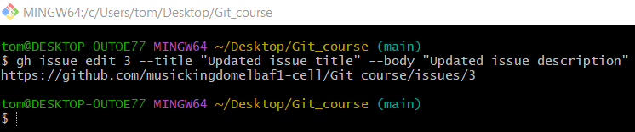
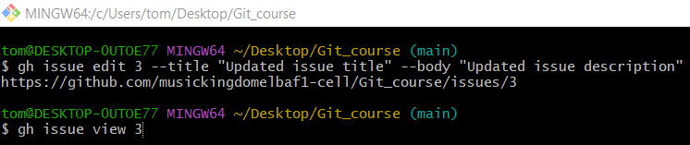
gh issue view 3
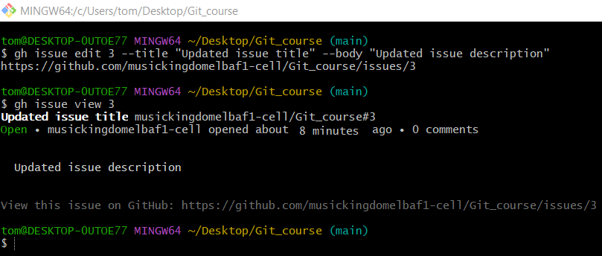

5️⃣ Assign an Issue
# Source: ScreenShots Source: Provided by: [Persons Table -> ID Column: 1, Name_En Column: Motasem Essam] -> Tool: [Lightshot Program] -> From [Operating System: Windows] on [3/6/2026]
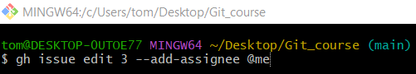
gh issue edit 3 --add-assignee @me
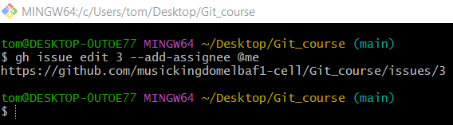
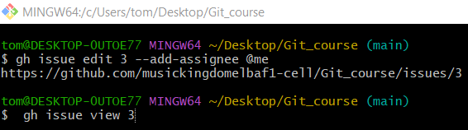
gh issue view 3

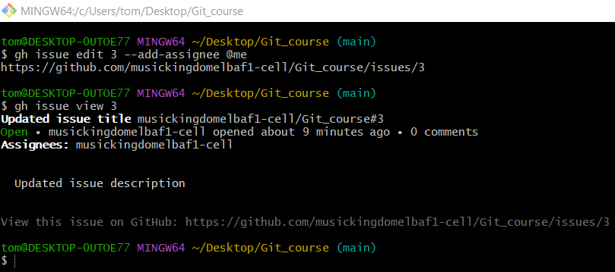

6️⃣ Add Labels
# Source: ScreenShots Source: Provided by: [Persons Table -> ID Column: 1, Name_En Column: Motasem Essam] -> Tool: [Lightshot Program] -> From [Operating System: Windows] on [3/6/2026]
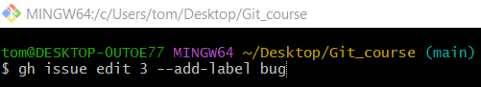
gh issue edit 3 --add-label bug
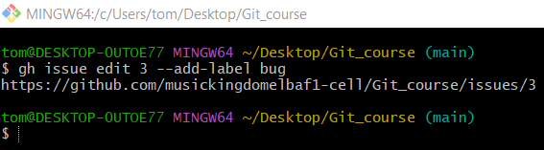
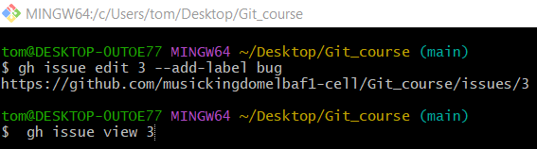
gh issue view 3
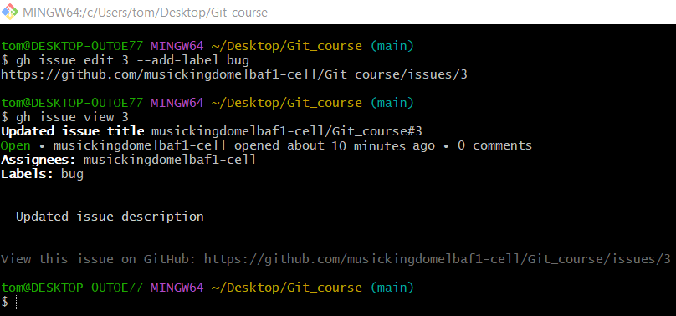

7️⃣ Comment on an Issue
# Source: ScreenShots Source: Provided by: [Persons Table -> ID Column: 1, Name_En Column: Motasem Essam] -> Tool: [Lightshot Program] -> From [Operating System: Windows] on [3/6/2026]
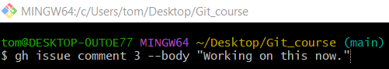
gh issue comment 3 --body "Working on this now."
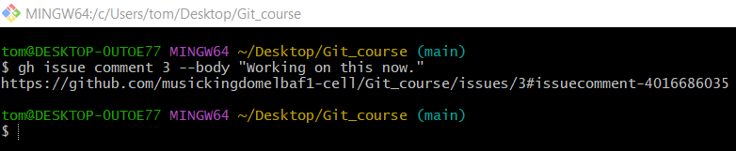
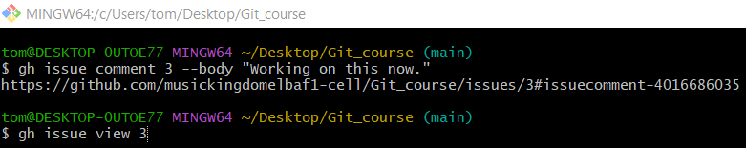
gh issue view 3
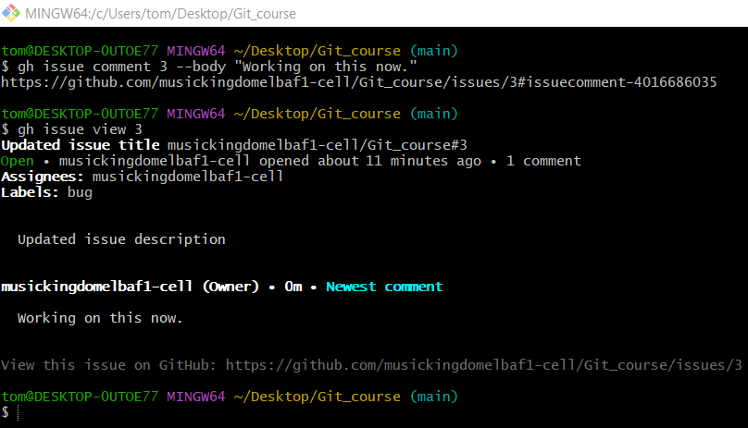

8️⃣ Close an Issue
# Source: ScreenShots Source: Provided by: [Persons Table -> ID Column: 1, Name_En Column: Motasem Essam] -> Tool: [Lightshot Program] -> From [Operating System: Windows] on [3/6/2026]
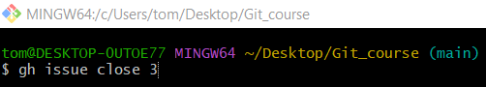
gh issue close 3
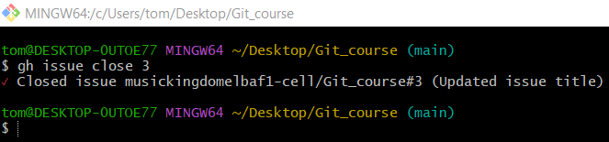
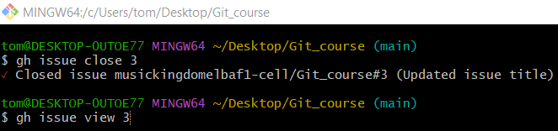
gh issue view 3
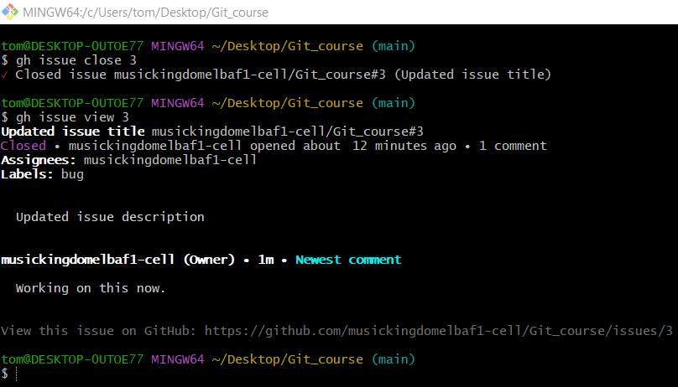

# Source: ScreenShots Source: Provided by: [Persons Table -> ID Column: 1, Name_En Column: Motasem Essam] -> Tool: [Lightshot Program] -> From [Site: https://github.com] on [3/6/2026]
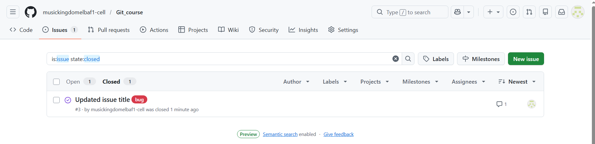

✅ Helpful command
# Source: ScreenShots Source: Provided by: [Persons Table -> ID Column: 1, Name_En Column: Motasem Essam] -> Tool: [Lightshot Program] -> From [Operating System: Windows] on [3/6/2026]
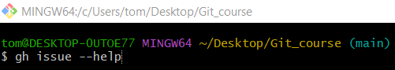
gh issue --help
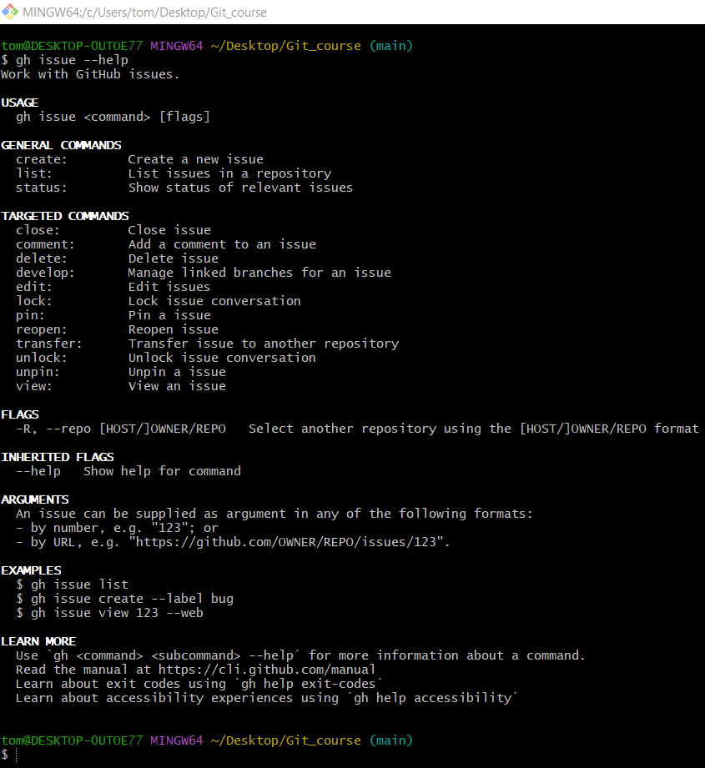

GitLab CLI: Working with Issues
# Source: AI Source: Provided by: [Data Path: Persons Table -> ID Column: 1, Name_En Column: Motasem Essam] -> From: [Chatgpt (GPT‑5 Mini)] on [3/6/2026]
The GitLab CLI lets you manage issues directly from the terminal without opening the browser. The CLI tool for GitLab is the GitLab CLI (command: glab), used with repositories hosted on GitLab.
Below are the most useful commands when working with issues.

1️⃣ Create a New Issue
# Source: AI Source: Provided by: [Data Path: Persons Table -> ID Column: 1, Name_En Column: Motasem Essam] -> From: [Chatgpt (GPT‑5 Mini)] on [3/6/2026]
Create issue directly:
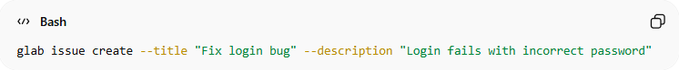
glab issue create --title "Fix login bug" --description "Login fails with incorrect password"
Interactive mode:
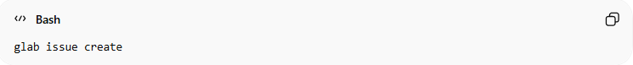
glab issue create
The CLI will ask for:
- title
- description
- labels
- assignee

2️⃣ List Issues
# Source: AI Source: Provided by: [Data Path: Persons Table -> ID Column: 1, Name_En Column: Motasem Essam] -> From: [Chatgpt (GPT‑5 Mini)] on [3/6/2026]
Show issues in the current repository:
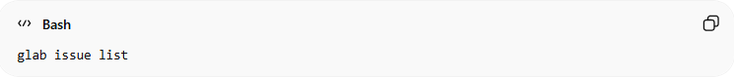
glab issue list
Example output:
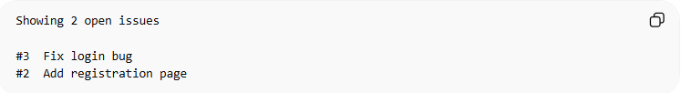
Showing 2 open issues
#3 Fix login bug
#2 Add registration page
Filter by state:
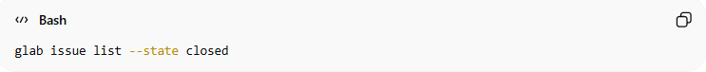
glab issue list --state closed
Other filters:
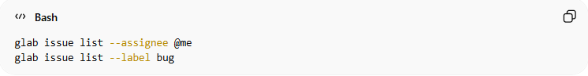
glab issue list --assignee @me
glab issue list --label bug

3️⃣ View an Issue
# Source: AI Source: Provided by: [Data Path: Persons Table -> ID Column: 1, Name_En Column: Motasem Essam] -> From: [Chatgpt (GPT‑5 Mini)] on [3/6/2026]
View issue details:
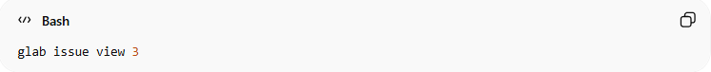
glab issue view 3
Open in browser:
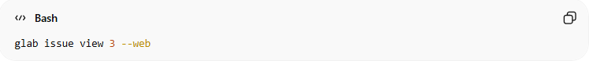
glab issue view 3 --web
This shows:
- title
- description
- labels
- comments
- status

4️⃣ Edit an Issue (GitLab CLI)
# Source: AI Source: Provided by: [Data Path: Persons Table -> ID Column: 1, Name_En Column: Motasem Essam] -> From: [Chatgpt (GPT‑5 Mini)] on [3/6/2026]
The GitLab CLI (glab) allows you to modify an existing issue directly from the terminal, such as updating the title or description.
Modify the issue title:
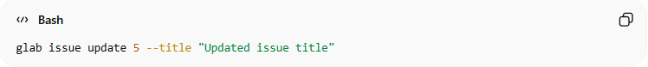
glab issue update 5 --title "Updated issue title"
Modify the issue description:
glab issue update 5 --description "Updated issue description"
Modify both title and description:
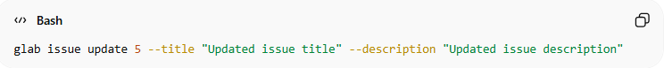
glab issue update 5 --title "Updated issue title" --description "Updated issue description"
Explanation:
- glab issue update → Updates an existing issue
- 5 → The issue number
- --title → Changes the issue title
- --description → Changes the issue description

5️⃣ Assign an Issue
# Source: AI Source: Provided by: [Data Path: Persons Table -> ID Column: 1, Name_En Column: Motasem Essam] -> From: [Chatgpt (GPT‑5 Mini)] on [3/6/2026]
Assign to yourself:
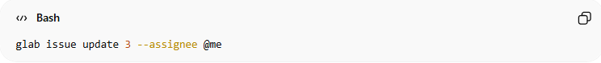
glab issue update 3 --assignee @me
Assign to another user:
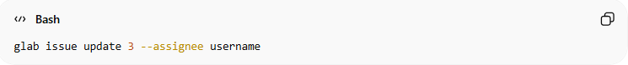
glab issue update 3 --assignee username
Remove yourself:
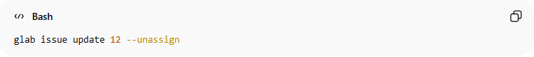
glab issue update 12 --unassign

6️⃣ Add Labels
# Source: AI Source: Provided by: [Data Path: Persons Table -> ID Column: 1, Name_En Column: Motasem Essam] -> From: [Chatgpt (GPT‑5 Mini)] on [3/6/2026]
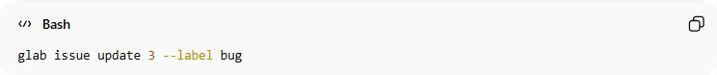
glab issue update 3 --label bug
Multiple labels:
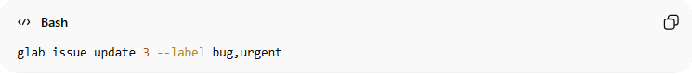
glab issue update 3 --label bug,urgent

7️⃣ Comment on an Issue
# Source: AI Source: Provided by: [Data Path: Persons Table -> ID Column: 1, Name_En Column: Motasem Essam] -> From: [Chatgpt (GPT‑5 Mini)] on [3/6/2026]
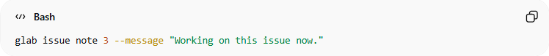
glab issue note 3 --message "Working on this issue now."

8️⃣ Close an Issue
# Source: AI Source: Provided by: [Data Path: Persons Table -> ID Column: 1, Name_En Column: Motasem Essam] -> From: [Chatgpt (GPT‑5 Mini)] on [3/6/2026]
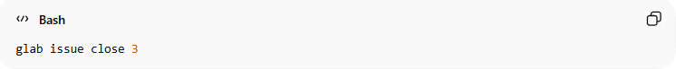
glab issue close 3
Reopen:
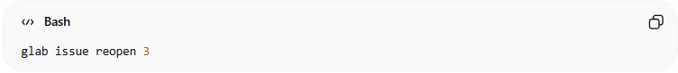
glab issue reopen 3

Example Developer Workflow 🚀
# Source: AI Source: Provided by: [Data Path: Persons Table -> ID Column: 1, Name_En Column: Motasem Essam] -> From: [Chatgpt (GPT‑5 Mini)] on [3/6/2026]
Typical workflow with GitLab Issues:
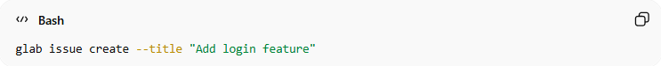
glab issue create --title "Add login feature"
Create branch:
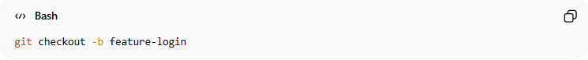
git checkout -b feature-login
Commit referencing issue:
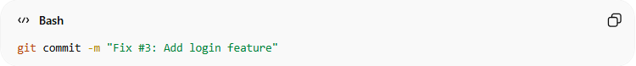
git commit -m "Fix #3: Add login feature"
Push branch:
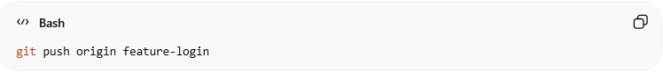
git push origin feature-login
Create merge request:
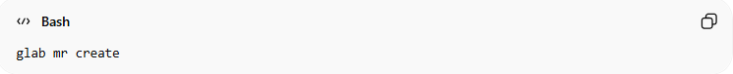
glab mr create
After merge → issue automatically closes.

✅ Helpful command
# Source: AI Source: Provided by: [Data Path: Persons Table -> ID Column: 1, Name_En Column: Motasem Essam] -> From: [Chatgpt (GPT‑5 Mini)] on [3/6/2026]
Run this to see all available commands:
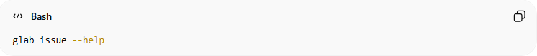
glab issue --help

💡 If you want, I can also show you the complete GitLab CLI workflow used by developers:
Issue → Branch → Commit → Push → Merge Request → Close Issue (step-by-step).

Example

1️⃣ Create a New Issue

Option 1: Create from the terminal
# Source: ScreenShots Source: Provided by: [Persons Table -> ID Column: 1, Name_En Column: Motasem Essam] -> Tool: [Lightshot Program] -> From [Operating System: Windows] on [3/6/2026]
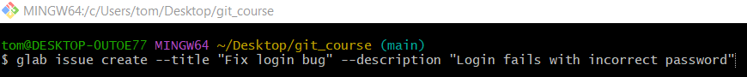
glab issue create --title "Fix login bug" --description "Login fails with incorrect password"
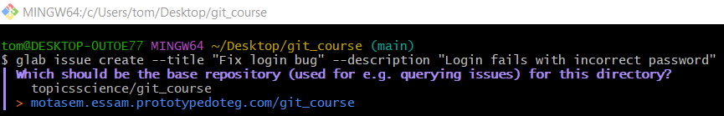
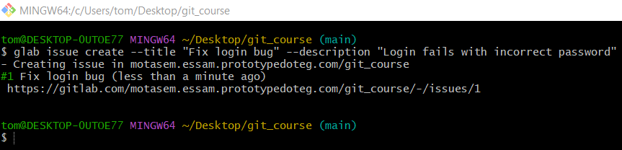

Option 2: Interactive mode
# Source: ScreenShots Source: Provided by: [Persons Table -> ID Column: 1, Name_En Column: Motasem Essam] -> Tool: [Lightshot Program] -> From [Operating System: Windows] on [3/6/2026]
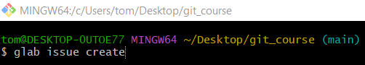
glab issue create
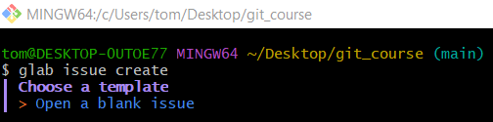
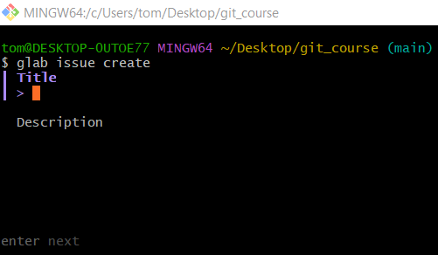
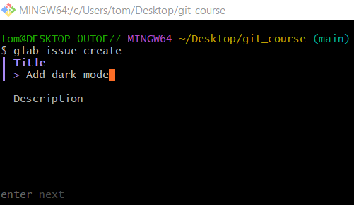
Add dark mode
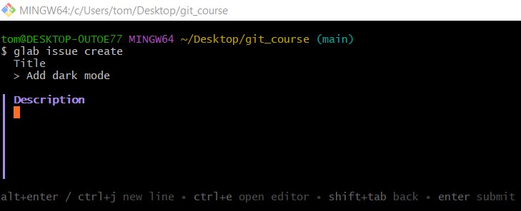
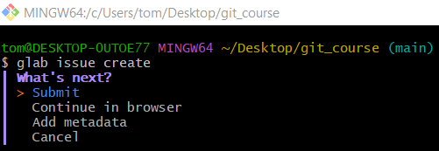
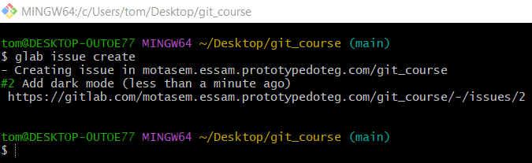

# Source: ScreenShots Source: Provided by: [Persons Table -> ID Column: 1, Name_En Column: Motasem Essam] -> Tool: [Lightshot Program] -> From [Site: https://gitlab.com] on [3/6/2026]
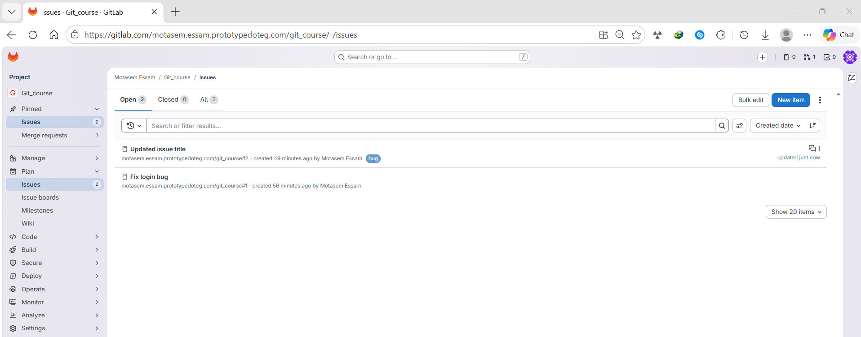

2️⃣ List Issues
# Source: ScreenShots Source: Provided by: [Persons Table -> ID Column: 1, Name_En Column: Motasem Essam] -> Tool: [Lightshot Program] -> From [Operating System: Windows] on [3/6/2026]
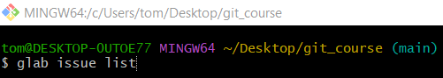
glab issue list
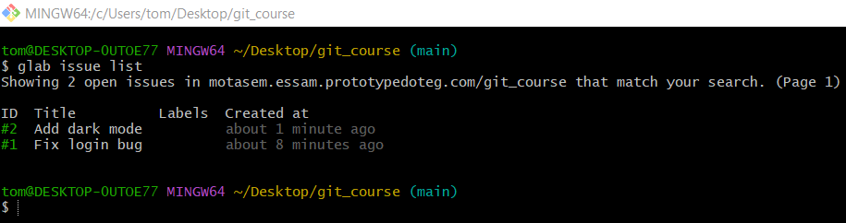

3️⃣ View an Issue
# Source: ScreenShots Source: Provided by: [Persons Table -> ID Column: 1, Name_En Column: Motasem Essam] -> Tool: [Lightshot Program] -> From [Operating System: Windows] on [3/6/2026]
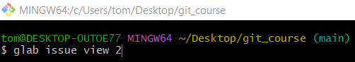
glab issue view 2
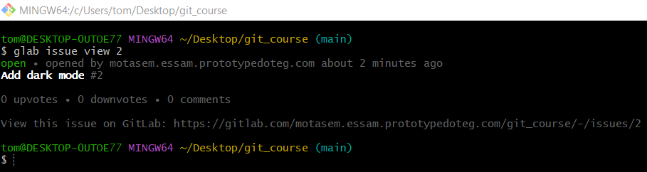

4️⃣ Edit an Issue
# Source: ScreenShots Source: Provided by: [Persons Table -> ID Column: 1, Name_En Column: Motasem Essam] -> Tool: [Lightshot Program] -> From [Operating System: Windows] on [3/6/2026]
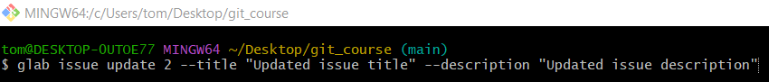
glab issue update 2 --title "Updated issue title" --description "Updated issue description"

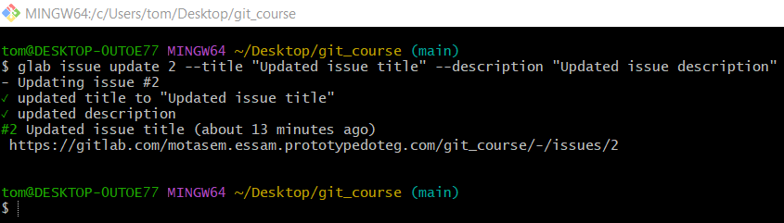
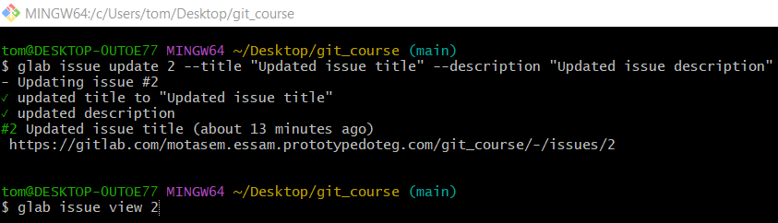
glab issue view 2
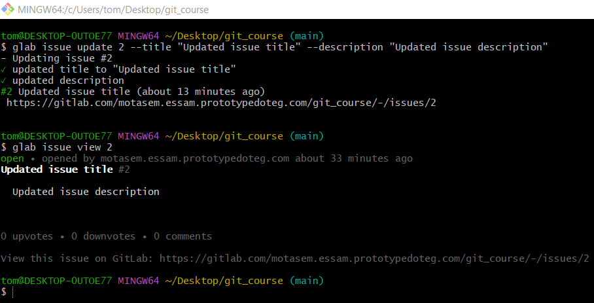

5️⃣ Assign an Issue
# Source: ScreenShots Source: Provided by: [Persons Table -> ID Column: 1, Name_En Column: Motasem Essam] -> Tool: [Lightshot Program] -> From [Operating System: Windows] on [3/6/2026]
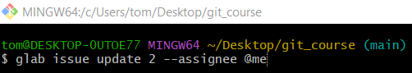
glab issue update 2 --assignee @me
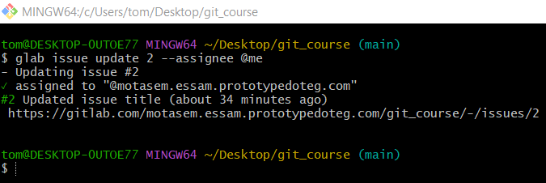
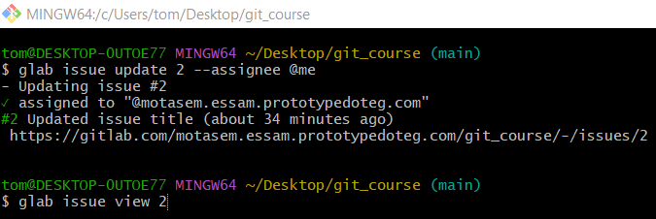
glab issue view 2
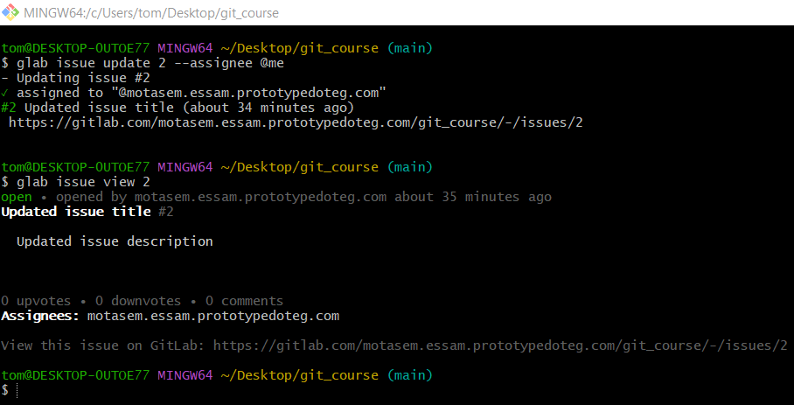

6️⃣ Add Labels
# Source: ScreenShots Source: Provided by: [Persons Table -> ID Column: 1, Name_En Column: Motasem Essam] -> Tool: [Lightshot Program] -> From [Operating System: Windows] on [3/6/2026]
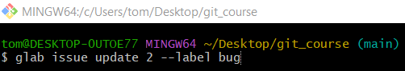
glab issue update 2 --label bug
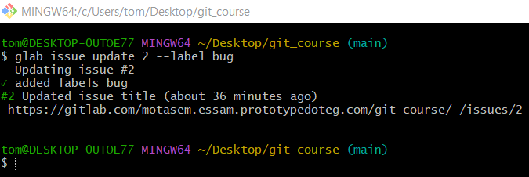
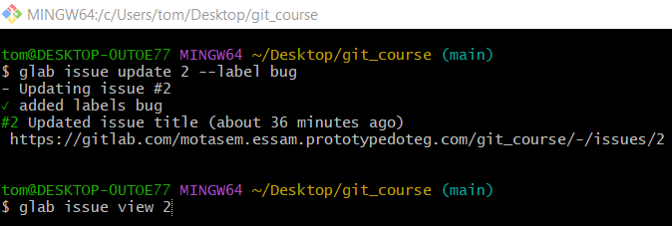
glab issue view 2
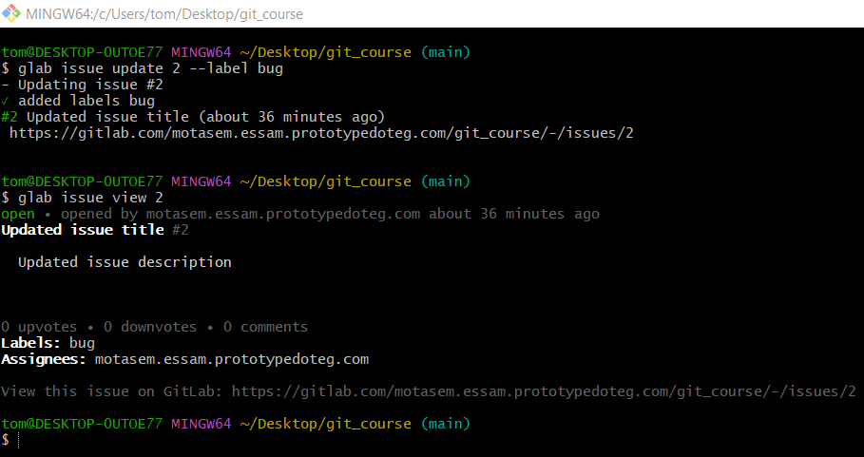

7️⃣ Comment on an Issue
# Source: ScreenShots Source: Provided by: [Persons Table -> ID Column: 1, Name_En Column: Motasem Essam] -> Tool: [Lightshot Program] -> From [Operating System: Windows] on [3/6/2026]
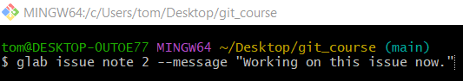
glab issue note 2 --message "Working on this issue now."
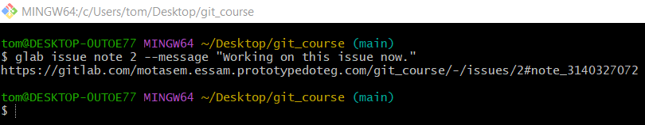
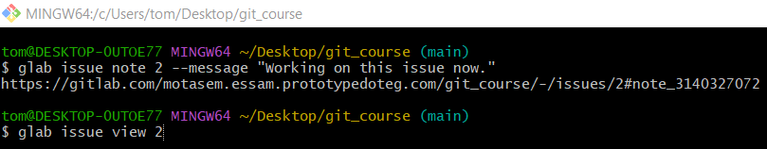
glab issue view 2
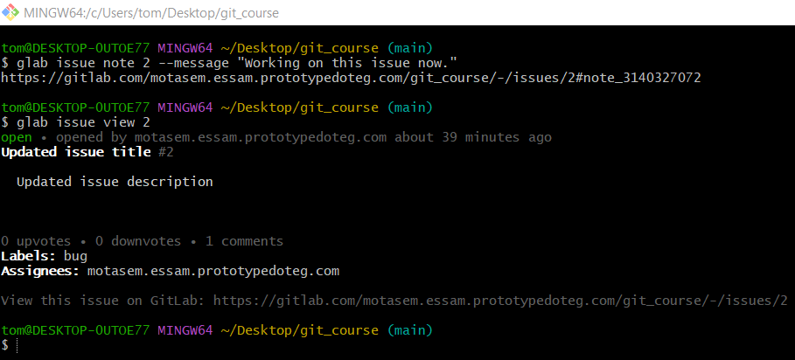

8️⃣ Close an Issue
# Source: ScreenShots Source: Provided by: [Persons Table -> ID Column: 1, Name_En Column: Motasem Essam] -> Tool: [Lightshot Program] -> From [Operating System: Windows] on [3/6/2026]
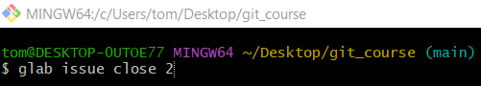
glab issue close 2
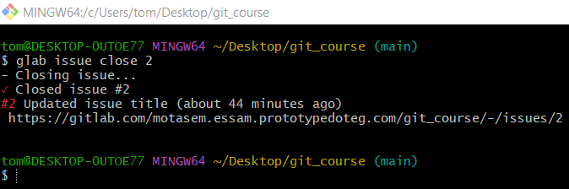
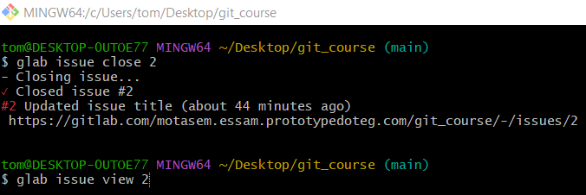
glab issue view 2
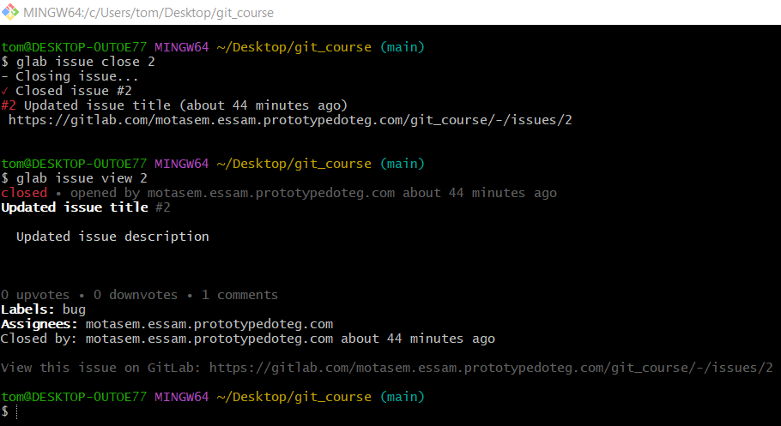

# Source: ScreenShots Source: Provided by: [Persons Table -> ID Column: 1, Name_En Column: Motasem Essam] -> Tool: [Lightshot Program] -> From [Site: https://gitlab.com] on [3/6/2026]
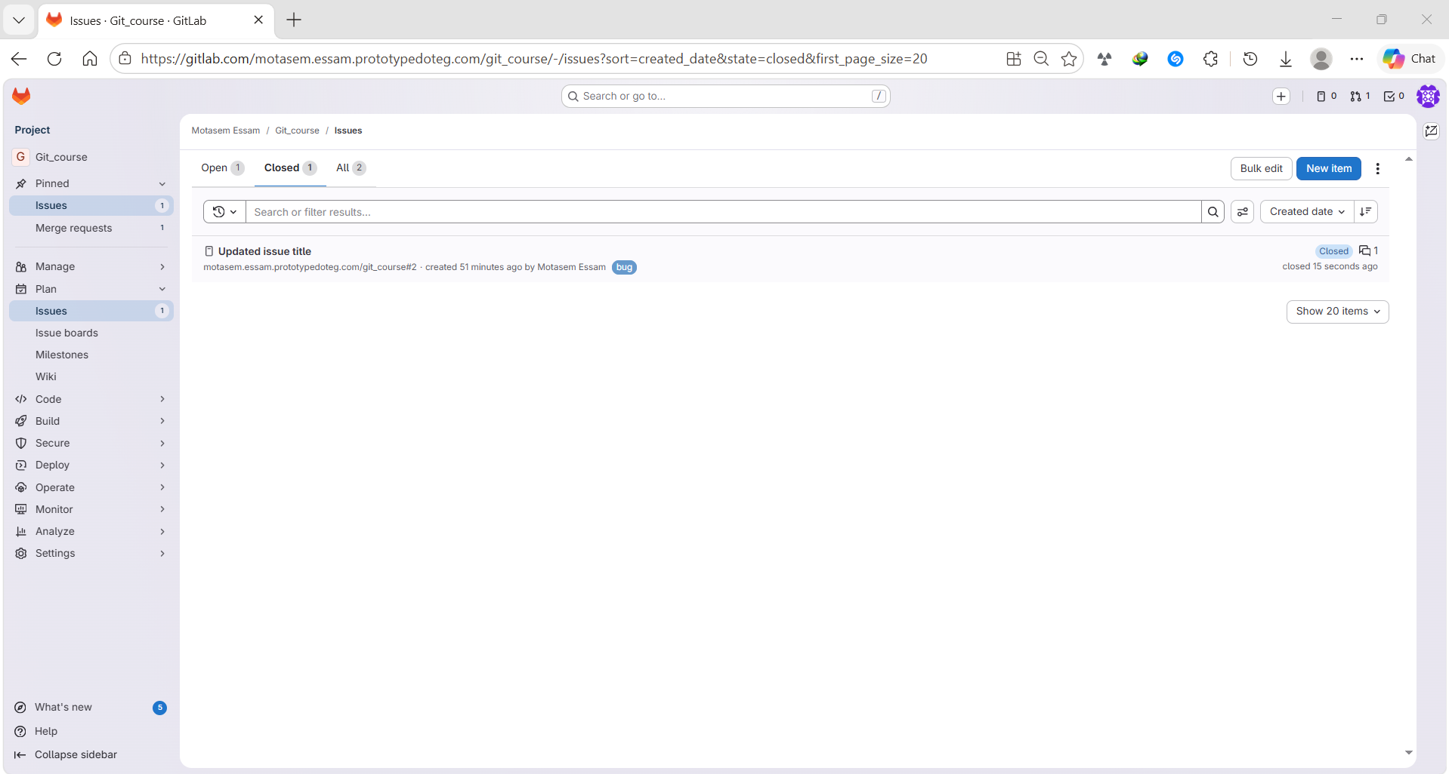

✅ Helpful command
# Source: ScreenShots Source: Provided by: [Persons Table -> ID Column: 1, Name_En Column: Motasem Essam] -> Tool: [Lightshot Program] -> From [Operating System: Windows] on [3/6/2026]
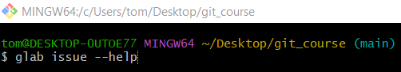
glab issue --help
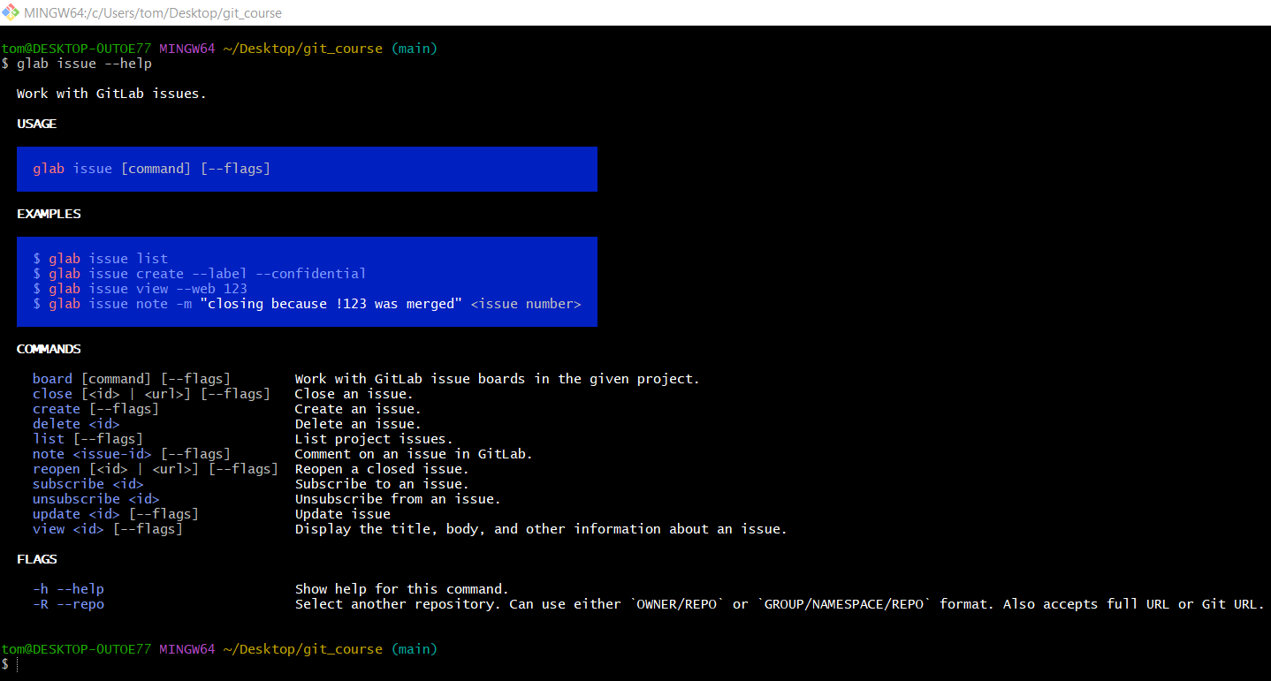

Quick Analogy
# Source: AI Source: Provided by: [Data Path: Persons Table -> ID Column: 1, Name_En Column: Motasem Essam] -> From: [Chatgpt (GPT‑5 Mini)] on [3/6/2026]
Think of Git issues like a to-do list integrated into your project:
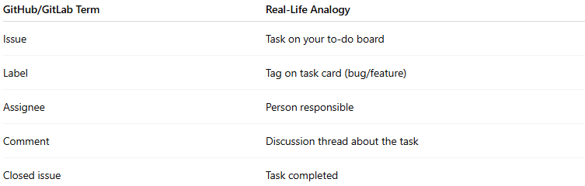
GitHub/GitLab Term | Real-Life Analogy
Issue | Task on your to-do board
Label | Tag on task card (bug/feature)
Assignee | Person responsible
Comment | Discussion thread about the task
Closed issue | Task completed

